**Name** :Karima Mokhtar Abdelmoamen Ahmed Eissa

**B.N :** 612

**Date:** 29/5/2020

**Topic :**Programming Languages

**The Definition of Programming Languages:** Programming is the implementation of logic to facilitate specified computing operations and functionality. It occurs in one or more languages, which differ by application, domain and programming model.

**Programming Languages and Their Uses:**

- Python is an open source programming language used by software engineering and Web developers at the back end. Python is well adapted to theoretical programming and learning is fairly simple

- Java is prevalent in Web-based development, and it was created in 1995. Many companies in the health sciences, education, and finance industries use Java. Java enables the downloading of applets from websites, which enable browsers to perform additional functions.

- C++, developed in 1983, is another middle-level programming language and works as an extension of C. Programmers use C++ to create games, graphics, and office applications.

- HTML is used extensively in Web development. HTML is the code that serves as the foundation of Web pages, allowing people to create and structure electronic documents for viewing online.

- JavaScript is used by Web developers and software engineers to manipulate page elements to make them more engaging. JavaScript enhances HTML, and it is embedded in most Internet browsers.

* PHP was released to the public in 1995. Developers use PHP as an open-source language to create dynamic Web pages. Widely used platforms such as Word Press and Drupal work cohesively with PHP.
* Apple uses the Swift programming language to create and maintain iOS and OS X applications. Swift 2 is a secondary open-source programming language more recently released by Apple.
* SQL enables programmers to create, read, update, and delete information in a database. Companies use SQL to gatherdata.

**Screenshots:**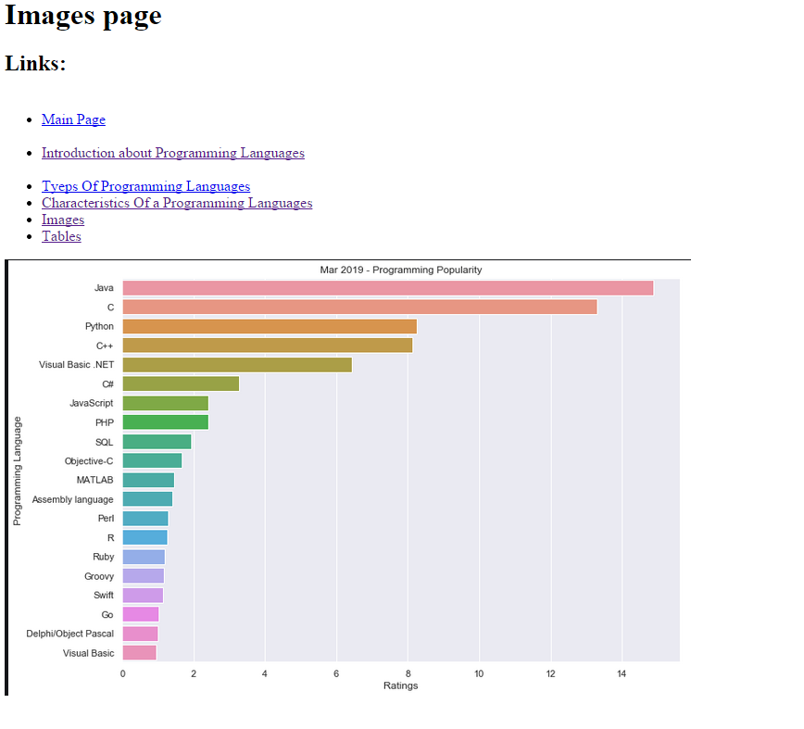

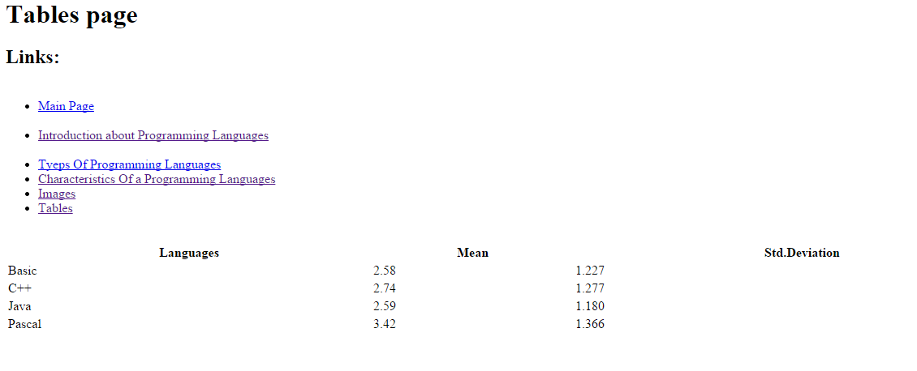

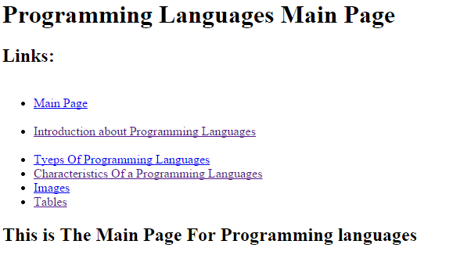

**Source code :**

